1-Mobile Network - SIM Card

📇 What Is a SIM Card?
# Source: Chatgpt (GPT-5-Mini) at [1/23/2026]
A SIM card (Subscriber Identity Module) is a small smart chip inserted into mobile devices that identifies and authenticates you to a mobile network. It allows you to make calls, send texts, and use mobile data.
Think of a SIM card as your phone's network ID badge — it tells the network who you are and what you're allowed to do.

🧠 What Does a SIM Card Do?
# Source: Chatgpt (GPT-5-Mini) at [1/23/2026]
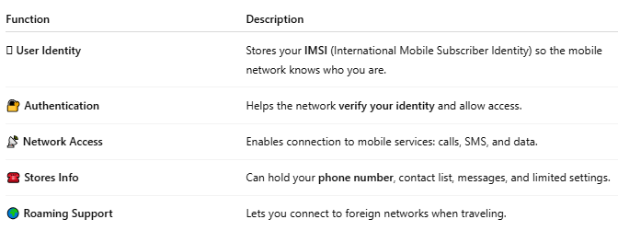

Function | Description
🪪 User Identity | Stores your IMSI (International Mobile Subscriber Identity) so the mobile network knows who you are.
🔐 Authentication | Helps the network verify your identity and allow access.
📡 Network Access | Enables connection to mobile services: calls, SMS, and data.
☎️ Stores Info | Can hold your phone number, contact list, messages, and limited settings.
🌍 Roaming Support | Lets you connect to foreign networks when traveling.

📦 What’s Inside a SIM Card?
# Source: Chatgpt (GPT-5-Mini) at [1/23/2026]
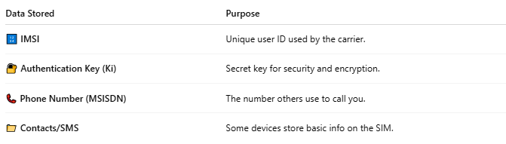

Data Stored | Purpose
🔢 IMSI | Unique user ID used by the carrier.
🔐 Authentication Key (Ki) | Secret key for security and encryption.
📞 Phone Number (MSISDN) | The number others use to call you.
📁 Contacts/SMS | Some devices store basic info on the SIM.

🔄 Types of SIM Cards:
# Source: Chatgpt (GPT-5-Mini) at [1/23/2026]
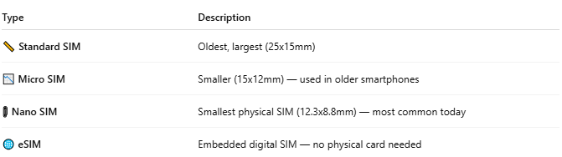

Type | Description
📏 Standard SIM | Oldest, largest (25x15mm)
📉 Micro SIM | Smaller (15x12mm) — used in older smartphones
📎 Nano SIM | Smallest physical SIM (12.3x8.8mm) — most common today
🌐 eSIM | Embedded digital SIM — no physical card needed

📱 SIM vs eSIM:
# Source: Chatgpt (GPT-5-Mini) at [1/23/2026]
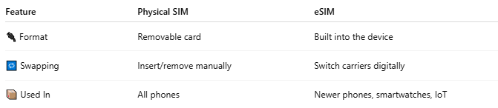

Feature | Physical SIM | eSIM
🔌 Format | Removable card | Built into the device
🔁 Swapping | Insert/remove manually | Switch carriers digitally
📦 Used In | All phones | Newer phones, smartwatches, IoT

🧩 Real-World Role in Mobile Networks:
# Source: Chatgpt (GPT-5-Mini) at [1/23/2026]
- You insert a SIM card into your phone.
- Your phone sends the IMSI to the network.
- The network checks your credentials (via HLR/HSS).
- If valid, it grants you access to voice, SMS, and internet.

📖 Summary:
# Source: Chatgpt (GPT-5-Mini) at [1/23/2026]
A SIM card is your phone’s digital passport to the mobile world. It stores your identity, authenticates you to the network, and enables you to access mobile services. Whether physical or digital (eSIM), it’s essential for connecting to any cellular network.

2-IMSI

🆔 What Is an IMSI?
# Source: Chatgpt (GPT-5-Mini) at [1/23/2026]
IMSI stands for International Mobile Subscriber Identity.
It is a unique number stored on your SIM card that identifies you as a subscriber to a mobile network.
Think of the IMSI as your true identity in the mobile world — it’s what your network uses to recognize and authenticate you.

🧬 IMSI Format
# Source: Chatgpt (GPT-5-Mini) at [1/23/2026]
An IMSI is usually 15 digits long and is structured like this:
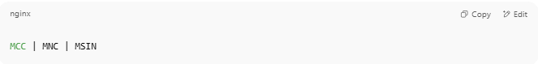
MCC | MNC | MSIN

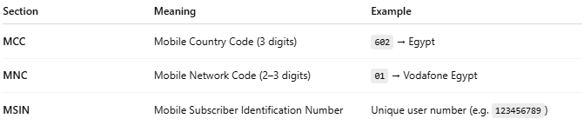
Section | Meaning | Example
MCC | Mobile Country Code (3 digits) | 602 → Egypt
MNC | Mobile Network Code (2–3 digits) | 01 → Vodafone Egypt
MSIN | Mobile Subscriber Identification Number | Unique user number (e.g. 123456789)
➡️ Example IMSI: 60201123456789

🧠 What Is the IMSI Used For?
# Source: Chatgpt (GPT-5-Mini) at [1/23/2026]
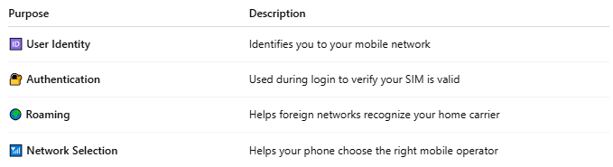

Purpose | Description
🆔 User Identity | Identifies you to your mobile network
🔐 Authentication | Used during login to verify your SIM is valid
🌍 Roaming | Helps foreign networks recognize your home carrier
📶 Network Selection | Helps your phone choose the right mobile operator

🔐 IMSI & Security
# Source: Chatgpt (GPT-5-Mini) at [1/23/2026]
- The IMSI is not normally sent in cleartext.
- A temporary ID called a TMSI (Temporary Mobile Subscriber Identity) is often used instead, to protect your privacy.
- The IMSI is only revealed during initial registration or in special cases.

📖 Summary:
# Source: Chatgpt (GPT-5-Mini) at [1/23/2026]
The IMSI is a globally unique ID number stored in your SIM card. It helps your mobile carrier identify you, authenticate your access, and connect you to services. While you rarely see it, it's one of the most critical parts of your mobile identity.

3-TMSI

🔐 What Is a TMSI?
# Source: Chatgpt (GPT-5-Mini) at [1/23/2026]
TMSI stands for Temporary Mobile Subscriber Identity.
It is a temporary, randomly assigned ID used by mobile networks to protect your real identity (IMSI) when you're connected to the network.
Think of the TMSI as a temporary alias or nickname for your SIM — it keeps your real identity (IMSI) hidden during communication.

🧠 Why Use TMSI?
# Source: Chatgpt (GPT-5-Mini) at [1/23/2026]
The IMSI is sensitive because it uniquely identifies you.
If it were transmitted often, it could be intercepted by attackers for tracking or impersonation.
So instead, the network uses a TMSI, which changes regularly to protect your privacy.

🔁 When and How TMSI Is Used:
# Source: Chatgpt (GPT-5-Mini) at [1/23/2026]
- 📱 Your phone turns on → sends IMSI to register with the network (just once).
- 🧠 Network assigns a TMSI → sends it back securely.
- 🔄 From now on, your phone uses TMSI to identify itself during communication.
- 🔁 TMSI may change periodically or when you change location (to prevent tracking).

🔐 TMSI Improves Security By:
# Source: Chatgpt (GPT-5-Mini) at [1/23/2026]
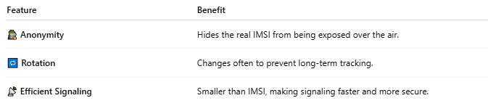

Feature | Benefit
🕵️ Anonymity | Hides the real IMSI from being exposed over the air.
🔁 Rotation | Changes often to prevent long-term tracking.
📡 Efficient Signaling | Smaller than IMSI, making signaling faster and more secure.

🧱 Where TMSI Is Stored:
# Source: Chatgpt (GPT-5-Mini) at [1/23/2026]
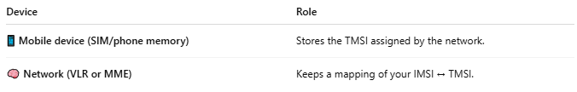

Device | Role
📱 Mobile device (SIM/phone memory) | Stores the TMSI assigned by the network.
🧠 Network (VLR or MME) | Keeps a mapping of your IMSI ↔ TMSI.

🔍 IMSI vs TMSI
# Source: Chatgpt (GPT-5-Mini) at [1/23/2026]
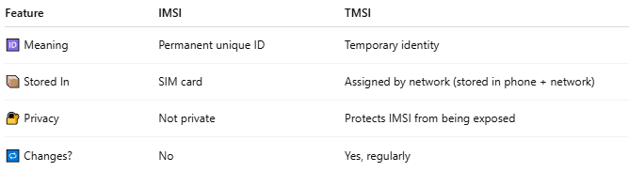

Feature | IMSI | TMSI
🆔 Meaning | Permanent unique ID | Temporary identity
📦 Stored In | SIM card | Assigned by network (stored in phone + network)
🔐 Privacy | Not private | Protects IMSI from being exposed
🔁 Changes? | No | Yes, regularly

📖 Summary:
# Source: Chatgpt (GPT-5-Mini) at [1/23/2026]
The TMSI is a temporary identity code that replaces your IMSI during mobile communication. It provides anonymity and security, protecting you from being tracked or hacked on the mobile network.

4-MSISDN

📞 What Is MSISDN?
# Source: Chatgpt (GPT-5-Mini) at [1/23/2026]
MSISDN stands for Mobile Station International Subscriber Directory Number.
It is the actual phone number assigned to a subscriber that others use to call or text them.
📱 It's what you dial when you call someone — like +20 100 123 4567

🧠 In Simple Terms:
# Source: Chatgpt (GPT-5-Mini) at [1/23/2026]
- MSISDN = Your Mobile Phone Number
- It is stored in the network, not on the SIM card
- It’s linked to the IMSI (which uniquely identifies your SIM)

🧩 Breakdown of MSISDN:
# Source: Chatgpt (GPT-5-Mini) at [1/23/2026]
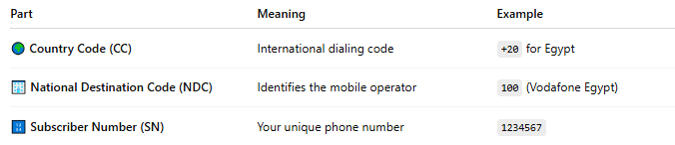

Part | Meaning | Example
🌍 Country Code (CC) | International dialing code | +20 for Egypt
🏢 National Destination Code (NDC) | Identifies the mobile operator | 100 (Vodafone Egypt)
🔢 Subscriber Number (SN) | Your unique phone number | 1234567
Full MSISDN Example: +20 100 1234567

🔁 MSISDN vs IMSI vs SIM
# Source: Chatgpt (GPT-5-Mini) at [1/23/2026]
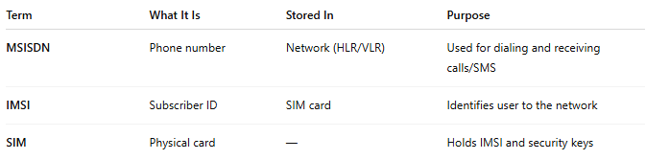

Term | What It Is | Stored In | Purpose
MSISDN | Phone number | Network (HLR/VLR) | Used for dialing and receiving calls/SMS
IMSI | Subscriber ID | SIM card | Identifies user to the network
SIM | Physical card | — | Holds IMSI and security keys

📦 Where MSISDN Is Used:
# Source: Chatgpt (GPT-5-Mini) at [1/23/2026]
- 📞 Routing voice calls
- 💬 Delivering SMS
- 📡 Identifying subscriber during call setup
- 💳 Billing/account linking
- 🛂 Roaming coordination

📖 Summary:
# Source: Chatgpt (GPT-5-Mini) at [1/23/2026]
- MSISDN = The number people use to call or text you
- It's stored in the mobile network, not your SIM
- It links to your IMSI to connect real-world dialing with the internal network identity

